# SLM Process Data from the SMF Database

Service Level Management

**Purpose**

Service Level Agreements for deliverables such as file transmits and reports are monitored and reported on through the System Management Facility (SMF) database. TWS jobs that are pre-defined within Access report completion times to the SMF database and are processed via Access in order to appear on the SLA Report.

**Related Policy**

* [IT Service Management Policy](https://sharepoint.jackson.com/sites/integrity/_layouts/15/WopiFrame.aspx?sourcedoc=%7be34fe42a-654a-469a-9d38-6612f00486dc%7d&action=view)

**Audience**

The following groups are responsible for adhering to this document:

* Service Level Management

**Procedure**

|  |  |
| --- | --- |
| Step | Action |
| 1 | Locate the *Cycle Status Database Transmits.accdb* file at the following location:  S:\TECHNOLG\Production_Support\Reports\SLA Monthly  The most current *Cycle Status Database Transmits.accdb* file is located in the current *YYYY Reports* folder. |
| 2 | Update the Cycle Status Database Transmits file:   1. Double click on the *Cycle Status Database Transmits.accdb* from Step 1 to open. 2. Double Click on “1-Load_To__Job_Data_For_Date_Of_Cycle_tbl”, listed under “Queries”.      1. Click the “Yes” button when the following message appears:      1. Type in the previous day’s cycle date. Format MM/DD/YYYY 2. Click the “OK” button.      1. Type in your mainframe logon credentials. 2. Click the “OK” button.      1. Click the “Yes” button when the following message appears. |
| 3 | Review the data that has been uploaded to the Access Database:   1. Double click on “Job_Data_Data_For_Date_of_Cycle”, listed under “Tables”.      1. Ensure that there are times listed in the “End_TS” and “End_TS_AsString” columns for each job for the cycle date that was run. See ***Appendix A*** for description of each column in the Access Database.      1. If these two fields are empty, view the job in TWS on the Mainframe (JNL1) to obtain the completion time. See ***Appendix B*** for more information. 2. Do not continue to Step 4 until completion times have been manually entered into the Access database. In the event that a job has not run   yet, you will have to wait until the job has completed to finish this procedure.  ***Note:*** *To view a color coded report that indicates if the SLAs were breached or not, see*  ***Appendix C.*** |
| 4 | Load data into the DB2DBA Event History database:   1. Double click on “2-DST_DTCC_Job_Data_Into_Event_History_PROD”, located under “Queries”.      1. Click the “Yes” button when the following message appears.      1. Click the “Yes’ button when the following box appears. 2. Type in the previous day’s cycle date. Format MM/DD/YYYY 3. Click the “OK” button.      1. If prompted for your user ID and password, use your network logon credentials. The Database that is being accessed is “SLAP”. 2. Click the “Yes” button when the following box appears. |
| 5 | Load data into the PROD SLA database:   1. Double click on “3-Load_DST-DTCC_into_PROD_SLA”, located under “Queries”.      1. Click the “Yes” button when the following message appears.      1. Click the “Yes” button when the following message appears. |
| 6 | Follow the ***SLM_Running the SLA Load Utility*** Procedure to feed the information into the SLA Database. |

**Appendix A – Access Database Column Definitions**

1. **Cycle_D:** The Cycle Date of the TWS job that is being monitored for an SLA.
2. **Job_Name_X:** The TWS job name that is feeding information into the SMF Database.
3. **End_TS:** The date and time in which the TWS job completed on the Mainframe.
4. **END_TS_AsString:** The date and time in which the TWS job completed on the Mainframe.
5. **Job_Category_Desc:** The description of the TWS job that will appear on the SLA Report.
6. **Report_TS:** Indicates the time in which the “1-Load_To__Job_Data_For_Date_Of_Ccle_tbl” was updated in Step 1 of this procedure.
7. **App_Desc:** Shows the description of the job that is being monitored for an SLA.
8. **SLA_TWS:** This is the Service Target date and time that the TWS job must be completed by in order for it not to breach its SLA.
9. **Job_Category_Seq:** Shows the order in which the jobs will appear on the internal report that can be run within Access Database. See ***Appendix C*** for more information.

**Appendix B – Check job status and completion time in TWS**

1. Log on to the Mainframe.
2. Type “O.T” on the “Option” line.
3. Hit “Enter”.

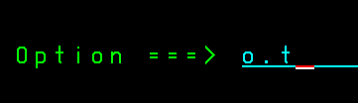

1. Type =5.3 on the “Option” line.

5 – Modify Current Plan

3 – Daily Planning

1. Hit “Enter”.
2. In the “Jobname” field, type the job name you are looking for.
3. Hit “Enter”.



1. The following information will appear. Ensure you are looking at the correct Cycle Date. Depending on what time of day this procedure is performed, there could be more than one job listed.
2. Look at the “S” (Status) column.
   * + “C” – job is completed
     + “S” – job is running
     + “W” – job is waiting to run.

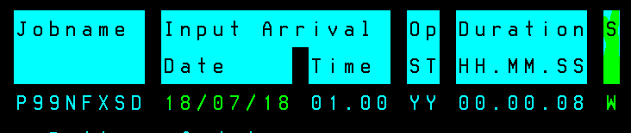

1. If job has a “C” status, type a “b” (“Browse Details”) at the front of the row.
2. Hit “Enter”.

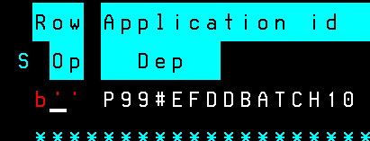

1. Type “2” on the “Option” line.
2. Hit “Enter”.
3. Under the “Actual” column, look for the “End” date and time. This information will need to be manually entered in to the “END_TS” and “END_TS_AsString” fields in the Access Database.

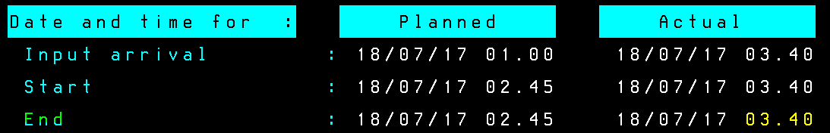

1. Verify that there is a JOBID number listed next to the job name. This indicates that the job actually ran and was no “No’Opd”.



1. Hit the “F3” button to back out of the screens.

Depending on what time of day this procedure is followed, you may have to access the “History” screen instead of the “Daily Planning” screen. If the job with the cycle date you are inquiring about is not listed under the “Daily Planning” screen, follow the procedure below.

1. Follow Steps 1 through 3 of Appendix C instructions above.
2. Type “7” on the “Option” line.

7 – Old Operations

1. Hit “Enter”.



1. In the “Jobname” field, type the job name you are looking for.
2. Hit “Enter”.



1. Type “Y” on the “Command” line.
2. Hit “Enter”.
3. A list of the past 30 job runs will appear. Locate the date you are looking for.
   * + Input Date – Indicates the Cycle Date
     + Actuate Date – Indicates the date the job was run.

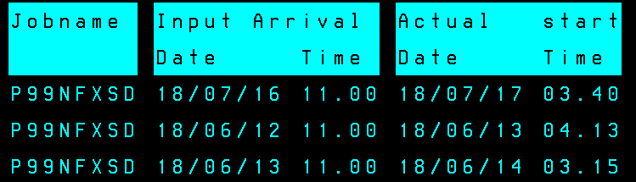

1. Follow Steps 12 through 16 of Appendix C instructions above.

**Appendix C – Run SMF SLA Report in Access Database**

Once Step 3 of this procedure has been completed, you can check to see if the SLAs were met or breached by running the JTS-SMF SLA Report within the Access Database.

1. Double click “JTS_SMF SLA Report”, located under “Reports”.

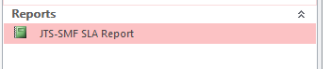

1. Type in the previous days’ cycle date.
2. Click the “OK” button.

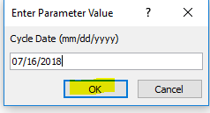

1. The following report will appear. If any of the jobs have breached their SLA, the entire row will be in yellow.

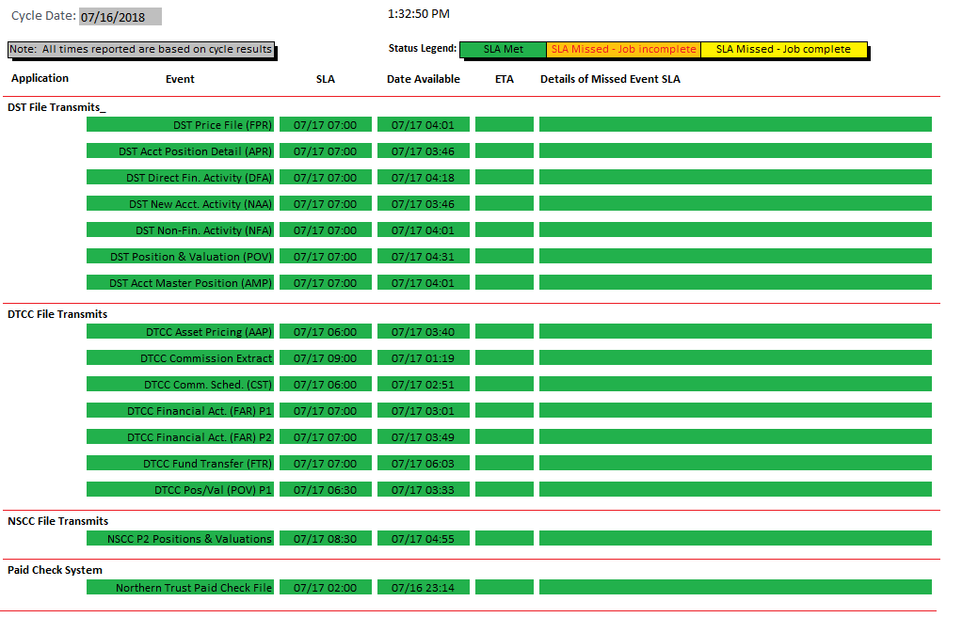

*Note: This report is not distributed or published.*

**Modification**

The following associates can make modifications to this document:

* Manager, Service Level Management
* Director, IT Service Management
* Vice President, Service Delivery
* Chief Technology Officer, PGDS

|  |  |
| --- | --- |
| Service Level Management Process | |
| Responsible Party: Anna Carter, Manager, Service Level Management Approving Authority: Abdul Golden, Director, IT Service Management | Date Created: 07/17/2018 Last Modified:  Last Reviewed: |